Week 9 Individual Logbook
Capstone project
Matt Baker
2026
Table of Contents
Hours Breakdown 2
Completed Content/Documentation 3
Team Meetings 3
Advisor Meetings 3
Client Meetings 3
Research 3
Documentation 4
Testing 6
Development 20

Hours Breakdown
Category | Hours completed
Team meetings
Client meetings
Advisor meetings
Research
Development
Testing
Documentation
Logbook preparation | 1 hr
Sick leave/specific conditions
Other
Total Hours for this week
Running total of hours completed for  Capstone | /450hrs

Completed Content/Documentation

Team Meetings
Monday, September 7th
10:00 – 2:30PM (2hrs 30mins)
Meeting with all present. We audited the logs, attempted to contact Bryce for a meeting, discussed his suggested meeting time from last week. We caught each other up on week 8’s activities. What will be done today. I read out and discussed slide by slide the mid project presentation descriptor and Q&A document.
Tuesday, September 8
10:00AM – 12:00PM (2hrs)
We troubleshoot some issues with fluffychat, discuss our interpretation of Bryces comments on my script, speak about what we can present in the presentation to Geoff, I demonstrate my scripts in real time.
Wednesday, September 9
2:30 – 4:00 PM (1 hr 30 mins)
Discussing and making decisions regarding the presentation, I relay the important features that should be expected in the presentation, especially the change in general philosophy of the project, the conciseness and the opportunities for Geoff to ask questions were topics I mentioned.
Advisor Meetings
Tuesday, September 8th
9:00 – 10:00AM (1hr)
Meeting with Bryce with all present, we spoke about our progress, he added us to his fluffychat, he clarifies that Ollama will probably not directly read the documents as the script I have produced does.
Thursday, September 10th
12-2:00PM (2hrs)
All present in a meeting with Bryce. He clarified that I only need my script to appropriate the audit.txt output of foremost and have AI format it with a cover page etc. We spoke of the nature of AI processing, the huggingface incident, HTOP and NVTOP, advice for presentation.

Client Meetings
Friday, September 11th
10AM-12PM (2hrs)
Meeting with Geoff with all present, discussing progress, emerging insights, preparing him for the mid project presentation interview.

Research

Documentation
Friday, September 11th
7:00 – 8:45 (1hr 45 minutes)
Adding my sections to the presentation, presenting emerging insights, the development and purpose of my scripts, and describing how this preliminary effort represents a core phase of this project: the integration of AI enhancement to digital forensics tools to produce comparable reports. As a part of this I practices

Testing
Tuesday, September 8
2:00 – 3:30 (1hr 30mins)
Based on Bryce’s feedback, he thinks I am going too far with my script but that the AI shouldn’t examine the files themselves. Instead, he believes the script should file carve by itself and create an output similar to that of the foremost “audit.txt” but as a forensic assistant. This began with testing another person’s python file carving tool from github and inspecting the code.
https://github.com/ShubhankarKulkarni/Data-Carving
Thursday. September 10
7:45 – 8:30 (45 minutes)
Testing a bunch of forensic disk images with my new reporting script “Ninemost”, primarily to make sure that the prompt restricts the format consistently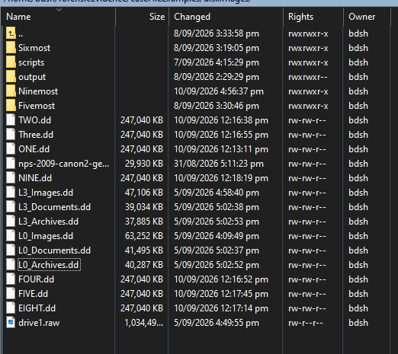
I noticed that sometimes it doesn’t mention the version of foremost used, so I explicitly add that into the prompt of the script. It also sometimes created a placeholder investigator name which I also changed the prompt for. Otherwise, the reports follow the same formatting well.
Friday, September 11
9:15 – 10:30 (1hr 15 min)
I was noticing my script sometimes did not put the name of the forensic disk image or the foremost version in the report, so I tested some different prompts, and ways of passing through the audit.txt, instead of catting the file and piping in the ollama prompt, I append the filename.
This source image and tool used are totally fabricated and false.
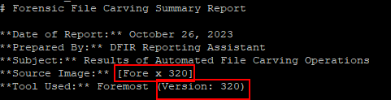

Testing if it is a prompt complexity issue, just asking the version of foremost still gives the same ignorance

Then test for an audit log length issue, the problematic details appear in the header, I try with a long file carve audit first.
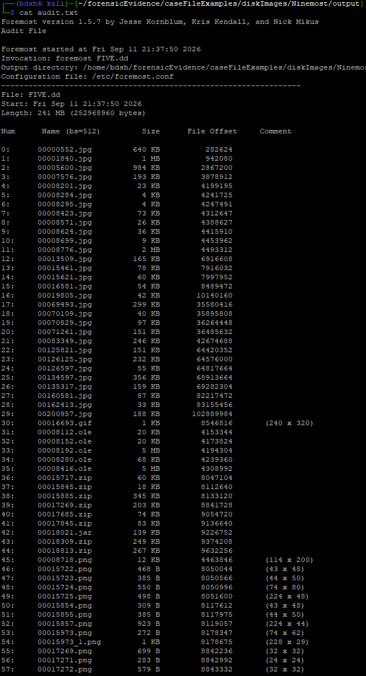
It cannot determine the version even though it’s right up there
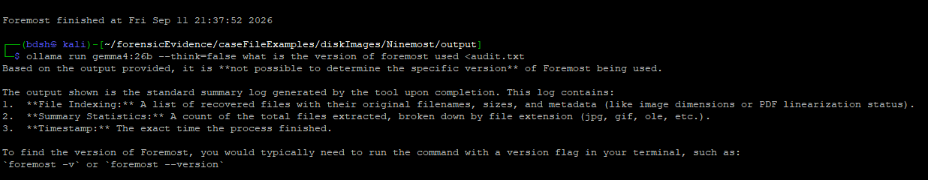
I try on a smaller audit.txt and it works
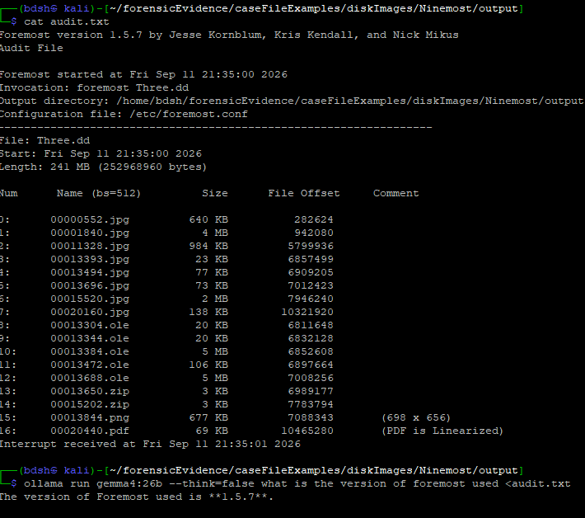

Development
Monday, September 7th
4:00 – 7:00PM (3hrs)
Improving the code of my “Fivemost” script by replacing the “os” module with “subprocess” module, this allows me more control over the Linux commands and is the intended way to go about this type of task in python.
The commands are segmented like so
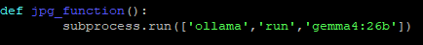
Rather than
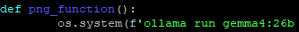

Final conversion, adjusted hierarchy because line too long.
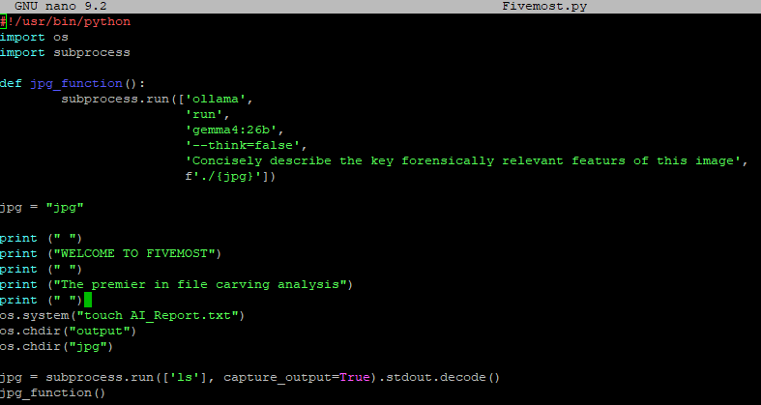
Learned and implemented appending the output of the command into a report .txt file. Working to have it append to the same text file located in the script’s directory. 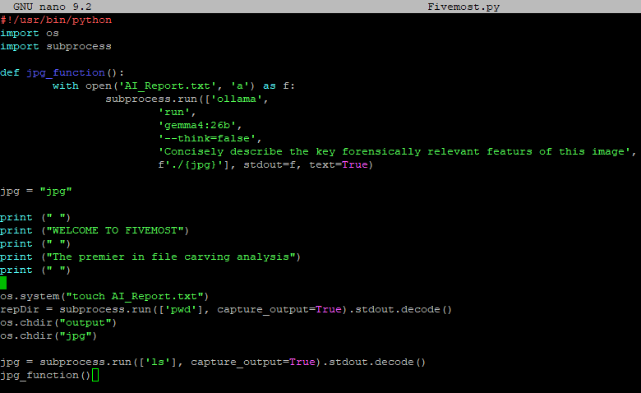
Modified script to save the running directory when the script starts (1) and prefix the report with it (2), so that multiple reports on different file types can be added to a single report, regardless of location.
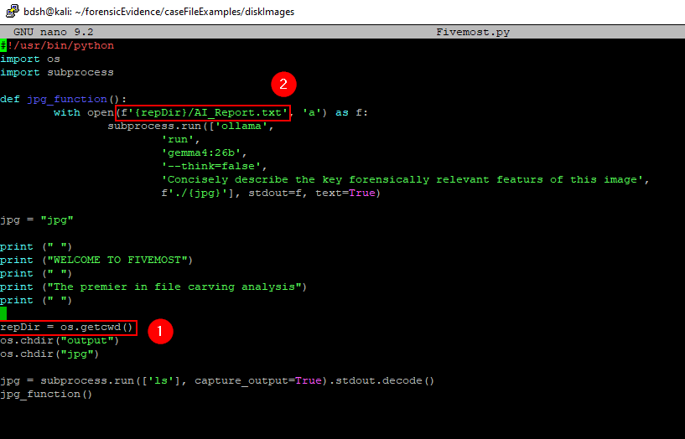
Re-added secondary file types and navigation, script changes directory to png container and grabs the “png” variable by “ls”, then the file name is passed in in the next function containing the ollama command outputted to the AI_Report.txt
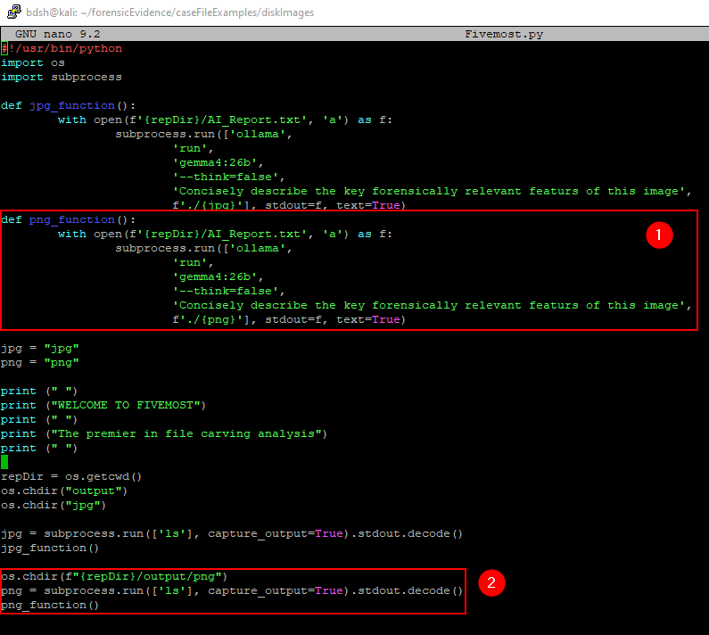
Here is the final script working. Writing the analysis of the two tools to a report file, then viewing the report.
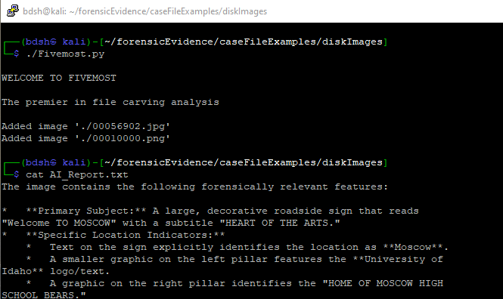
Wednesday, September 9th
7:00 – 10:15PM (3 hrs 15 min)
Based on an existing file carving code, I set out to make my own file carving tool that passes the data into Ollama to generate a basic report. For this I had to learn about key value pairs, dictionaries, json files and how to interact with them to append individual records of data, as each file has to have it’s data extracted individually after the carving steps.
Started with attempting to write a simple function that will consolidate the basic evidence details to be passed to ollama, creating an ordered list output is something that was missing in my first script (Fivemost).
This was done by writing them as individual file records that will be appended to a file record list in the form of a JSON file.
Here is the progress I made with this starting script which I annotated extensively.
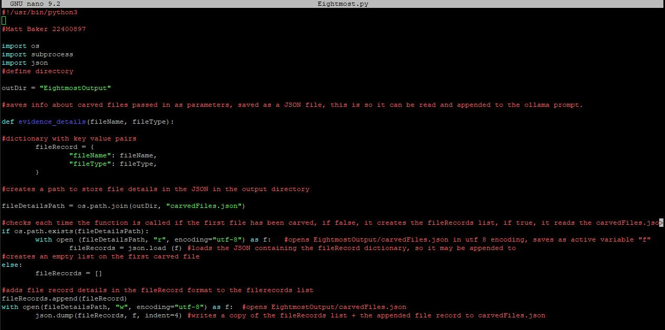
Thursday, September 10th
2:00 – 4:00PM (2hrs)
After my meeting with Bryce, it is now clear that I only need to have a python script that calls an ollama prompt that looks at the foremost audit.txt and produces a report based on it.
My previous efforts are not in vain, I apply and adapt what I learned and the code from “Fivemost” and “Eightmost”

“Ninemost” simply uses a direct shell command using subprocess to cat the audit.txt in the output directory of foremost, then pipe in the ollama command to process that audit file.
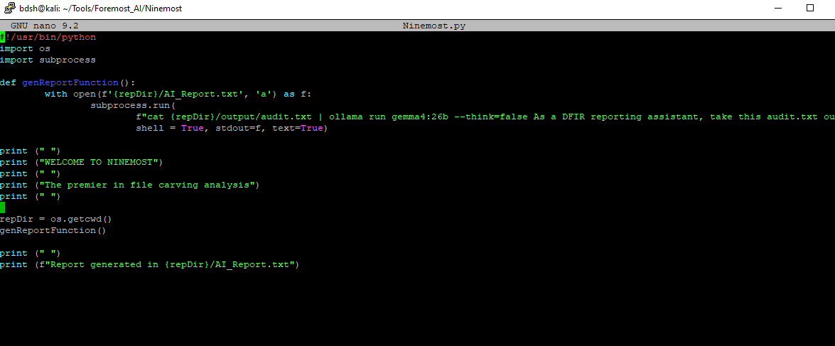

The report generated, a satisfactory and expected result.
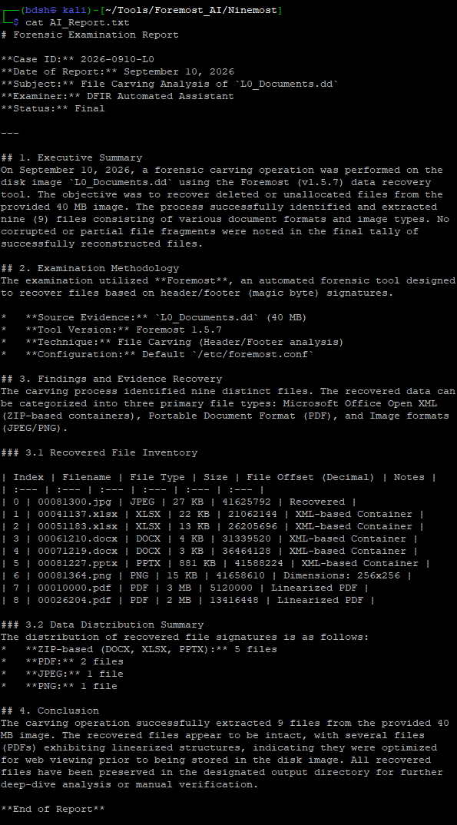
8:30 –10:45 (2hrs 15 min)
I added a timer that tells you how long the script took to run to two decimal places, this allows us to quantify the efficiency of this tool as opposed to a human.
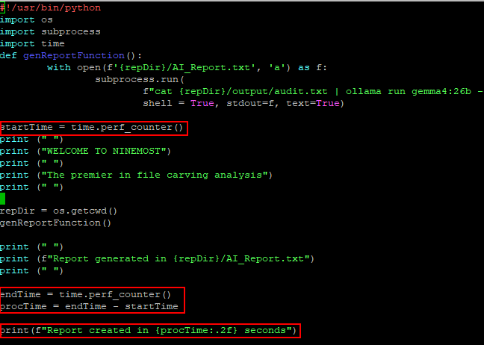
In execution
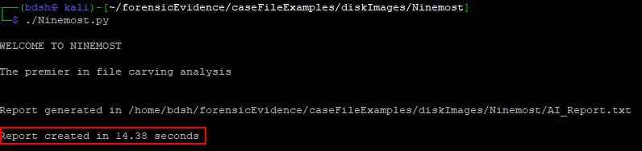
I pursue adding features from “Fivemost” too, the inspection of files, a single png, as a proof of concept that could be expanded.
To do this I append the entire report to the prompt as a variable. As you can see I have to be very explicit with the fact I want the entire original report back, as I was having trouble with it being overwritten with just the image description.
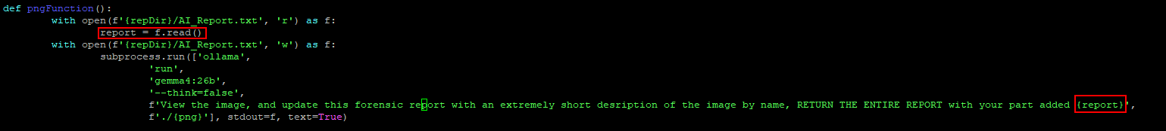
I still have some specific issues with the output being inconsistent, even with heavy and explicit prompt engineering. For example, sometimes it labels the image as “0” as if it has no context, this could be a context length issue or because the model lacks power. I just commented out the image processing part.
